N.S.P.R. GOVT. COLLEGE FOR WOMEN::HINDUPUR
DEPARTMENT OF MATHEMATICS
PERSONAL PROFILE
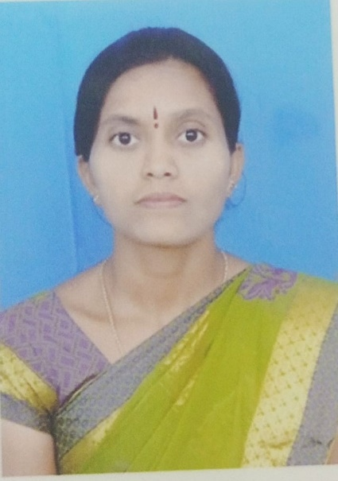
Smt. B. Sarada
Lecturer in Mathematics,
N.S.P.R. Degree College for Women, Hindupur.
Andhra Pradesh, India
Mobile : 9491799420
E-mail : saradab1991@gmail.com
TEACHING EXPERIENCE
COURSES TAUGHT | NAME OF THE COLLEGE | DURATION
Higher Secondary School | Deepthi , LRG Schools | 2016-2018
U. G. (B . SC.) | N.S.P.R.GOVERNMENT DEGREE COLLEGE FOR WOMEN , HINDUPUR | 01/02/2022 TO TILL DATE

Refresher Courses/Orientation Courses/Trainning Programmes attended:
SL.NO | COURSE | DATE | VENUE
1 | TOT ON ANALYTICAL SKILLS | 12/10/2022 TO 16/10/2022 | GOVT. DEGREE COLLEGE FOR MEN, ANANTAPUR
2 | TOT ON INTERNSHIP AND LMS | 02/02/2023 TO 04/02/2023 | GOVT. DEGREE COLLEGE FOR MEN, ANANTAPUR
3 | TOT ON PROFICIENCY IN ENGLISH | 19/06/2023 TO 24/06/2023 | GOVT. DEGREE COLLEGE FOR MEN, ANANTAPUR

